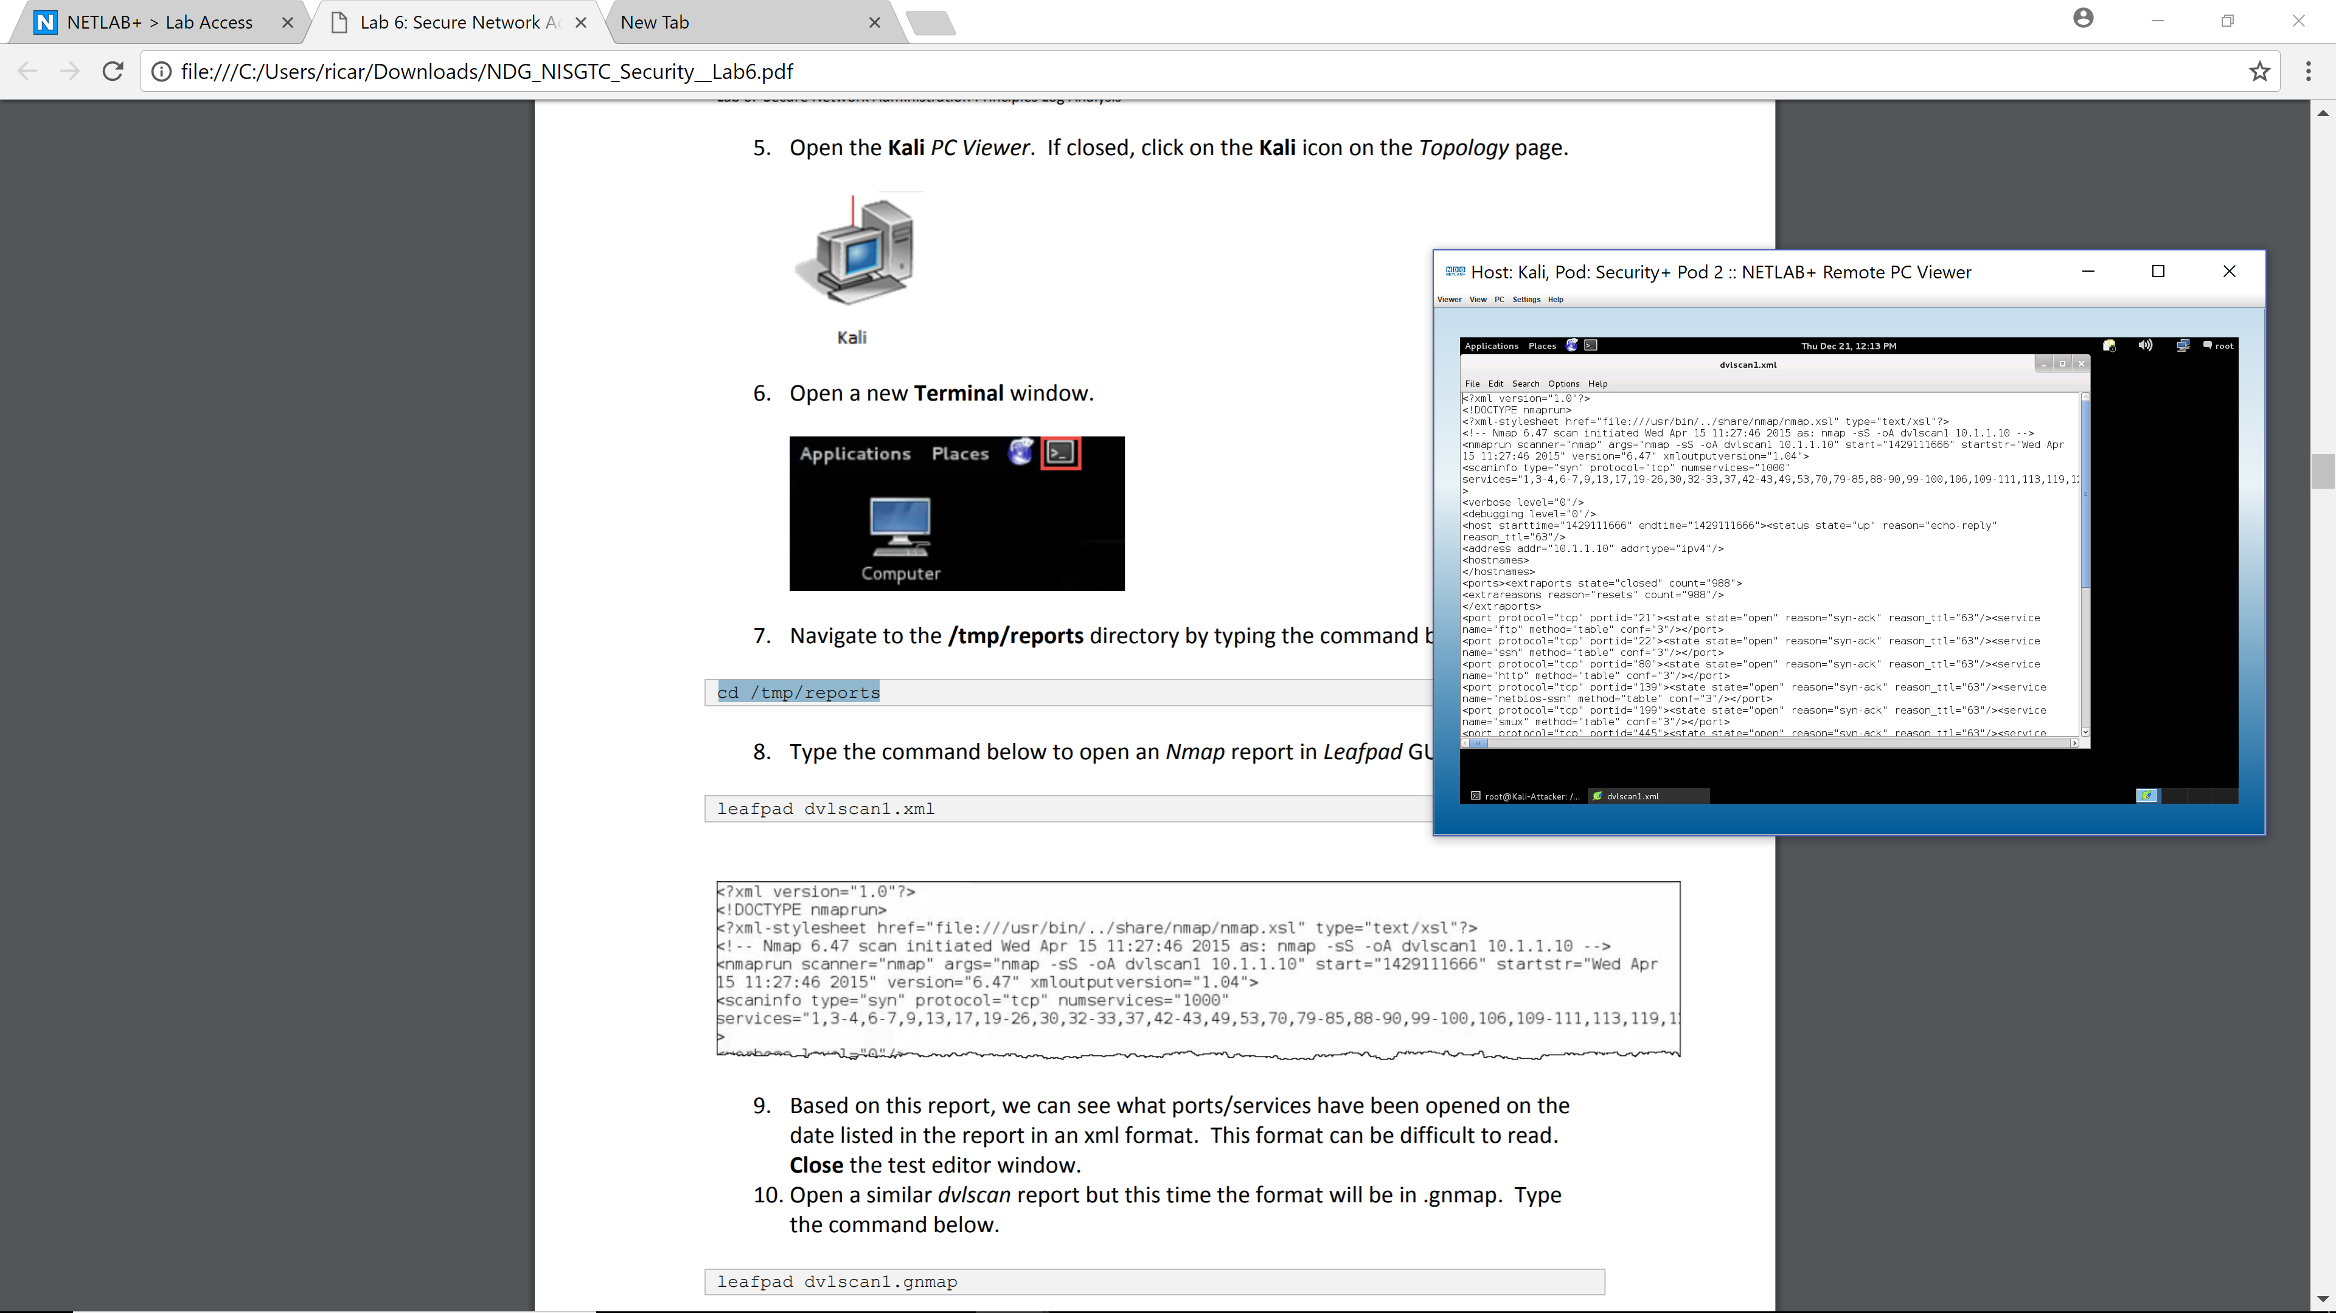
In this screen we are change directory to reports in tmp and then check for the ports that have been opened.

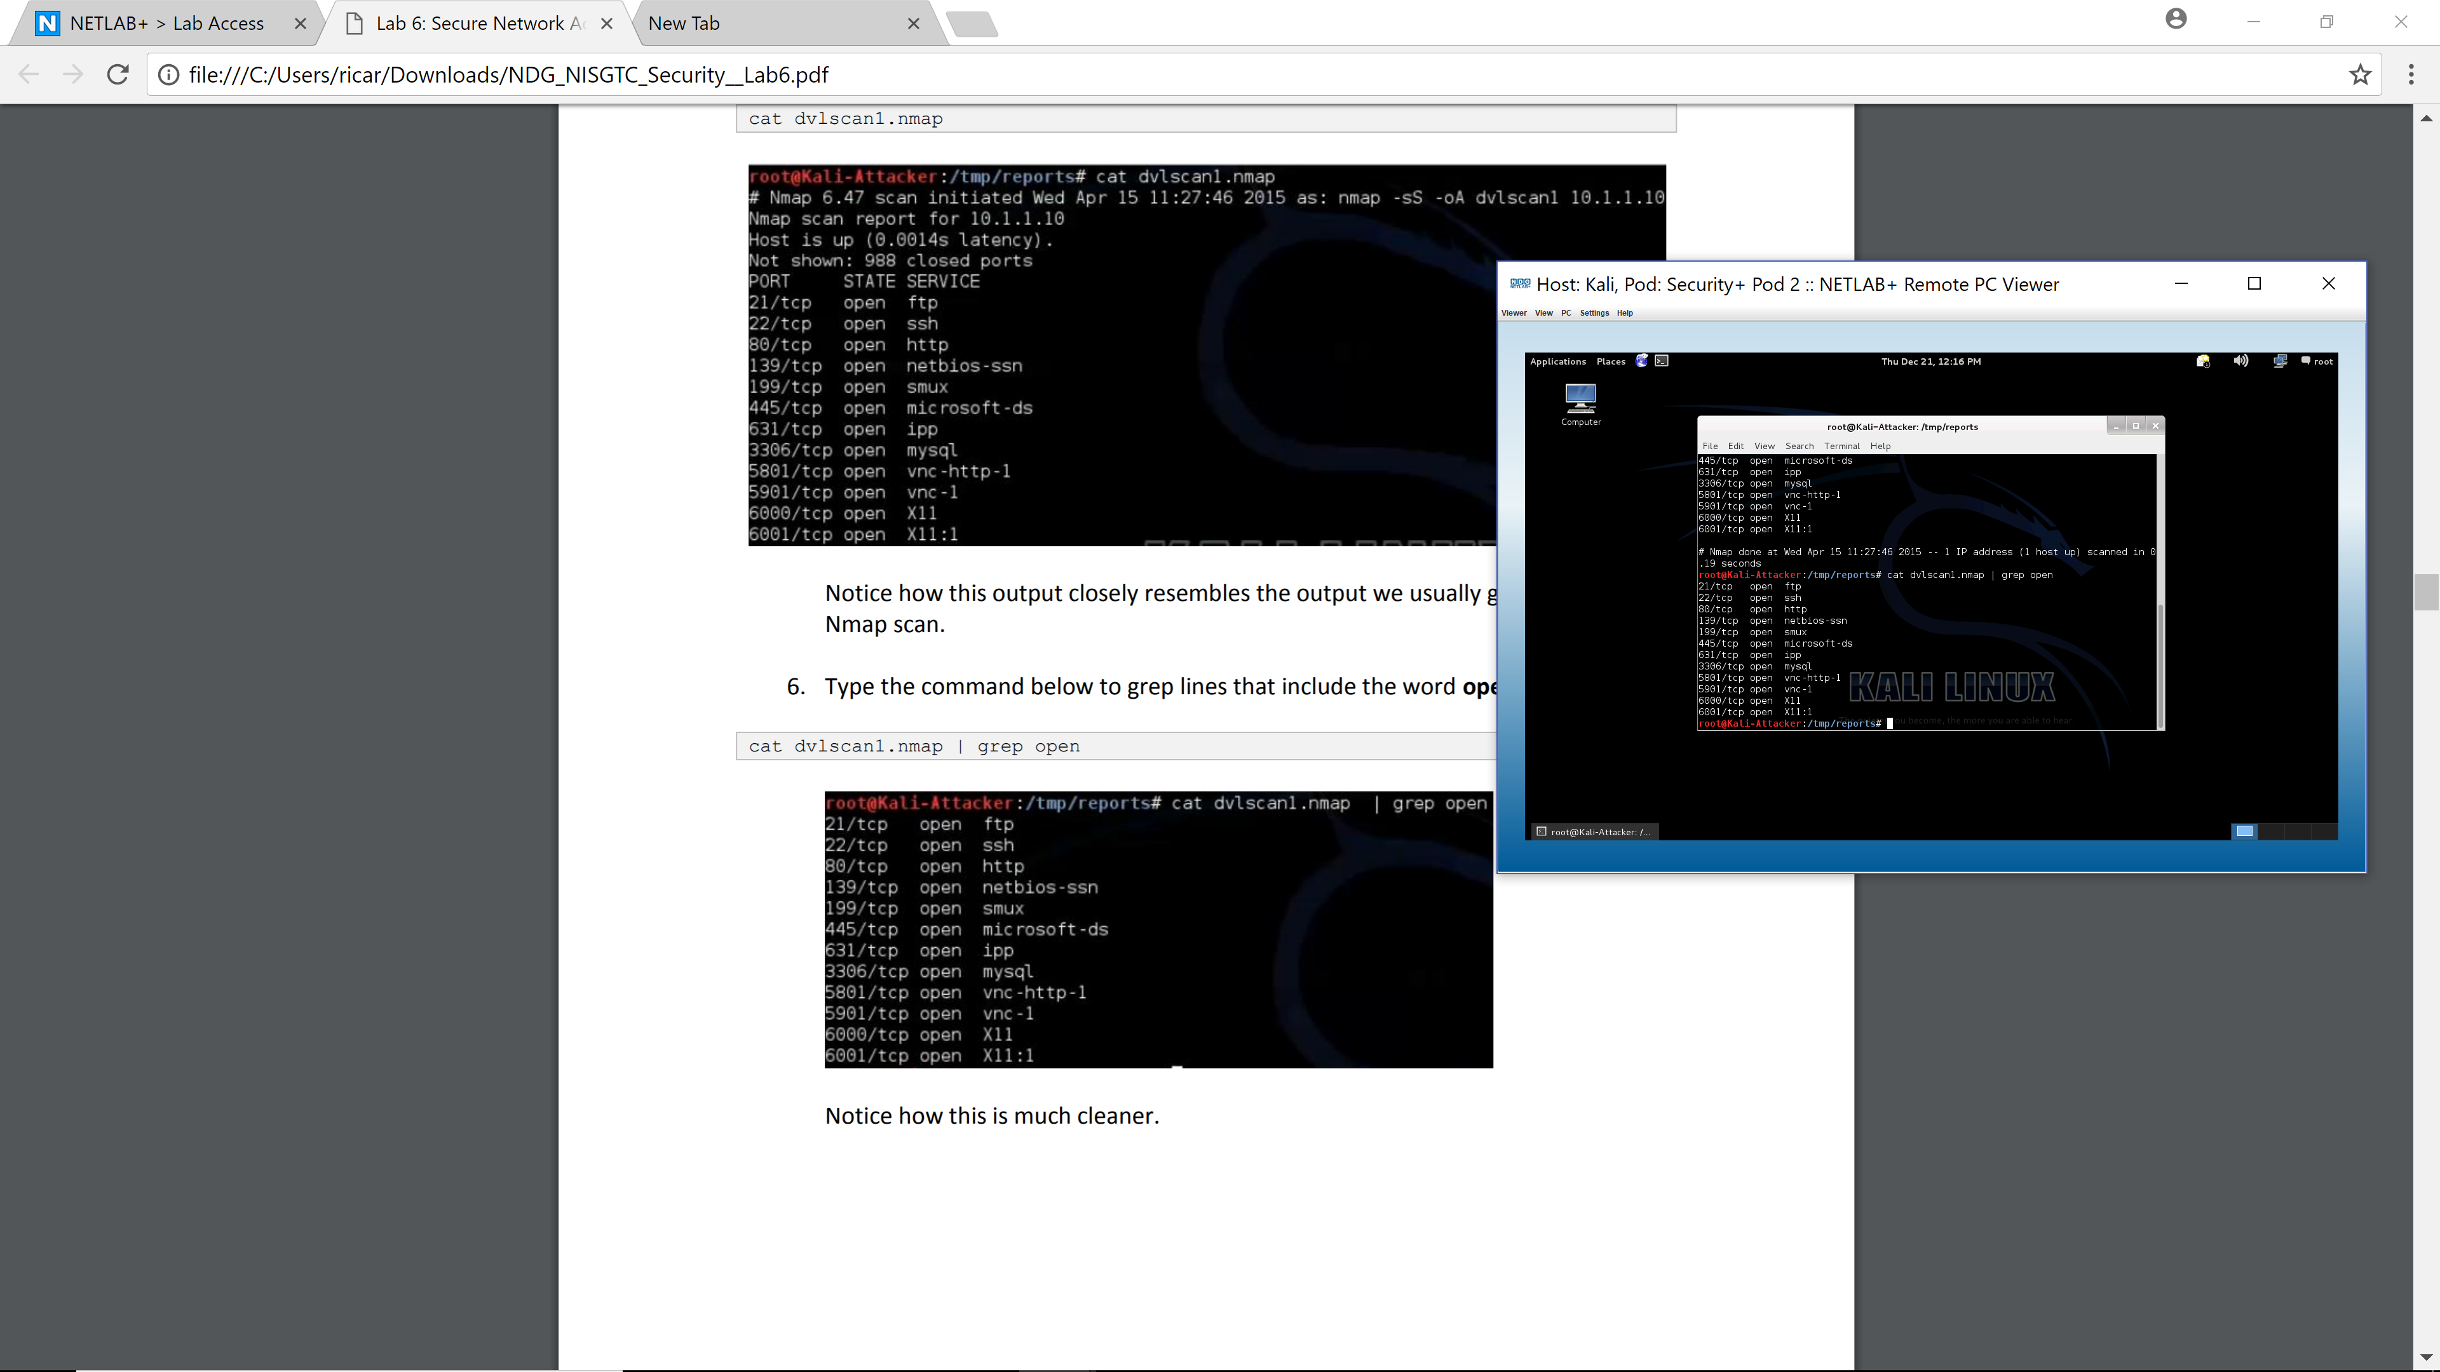
Later on this screen grep displays the word “open”, which is a lot more cleaner.
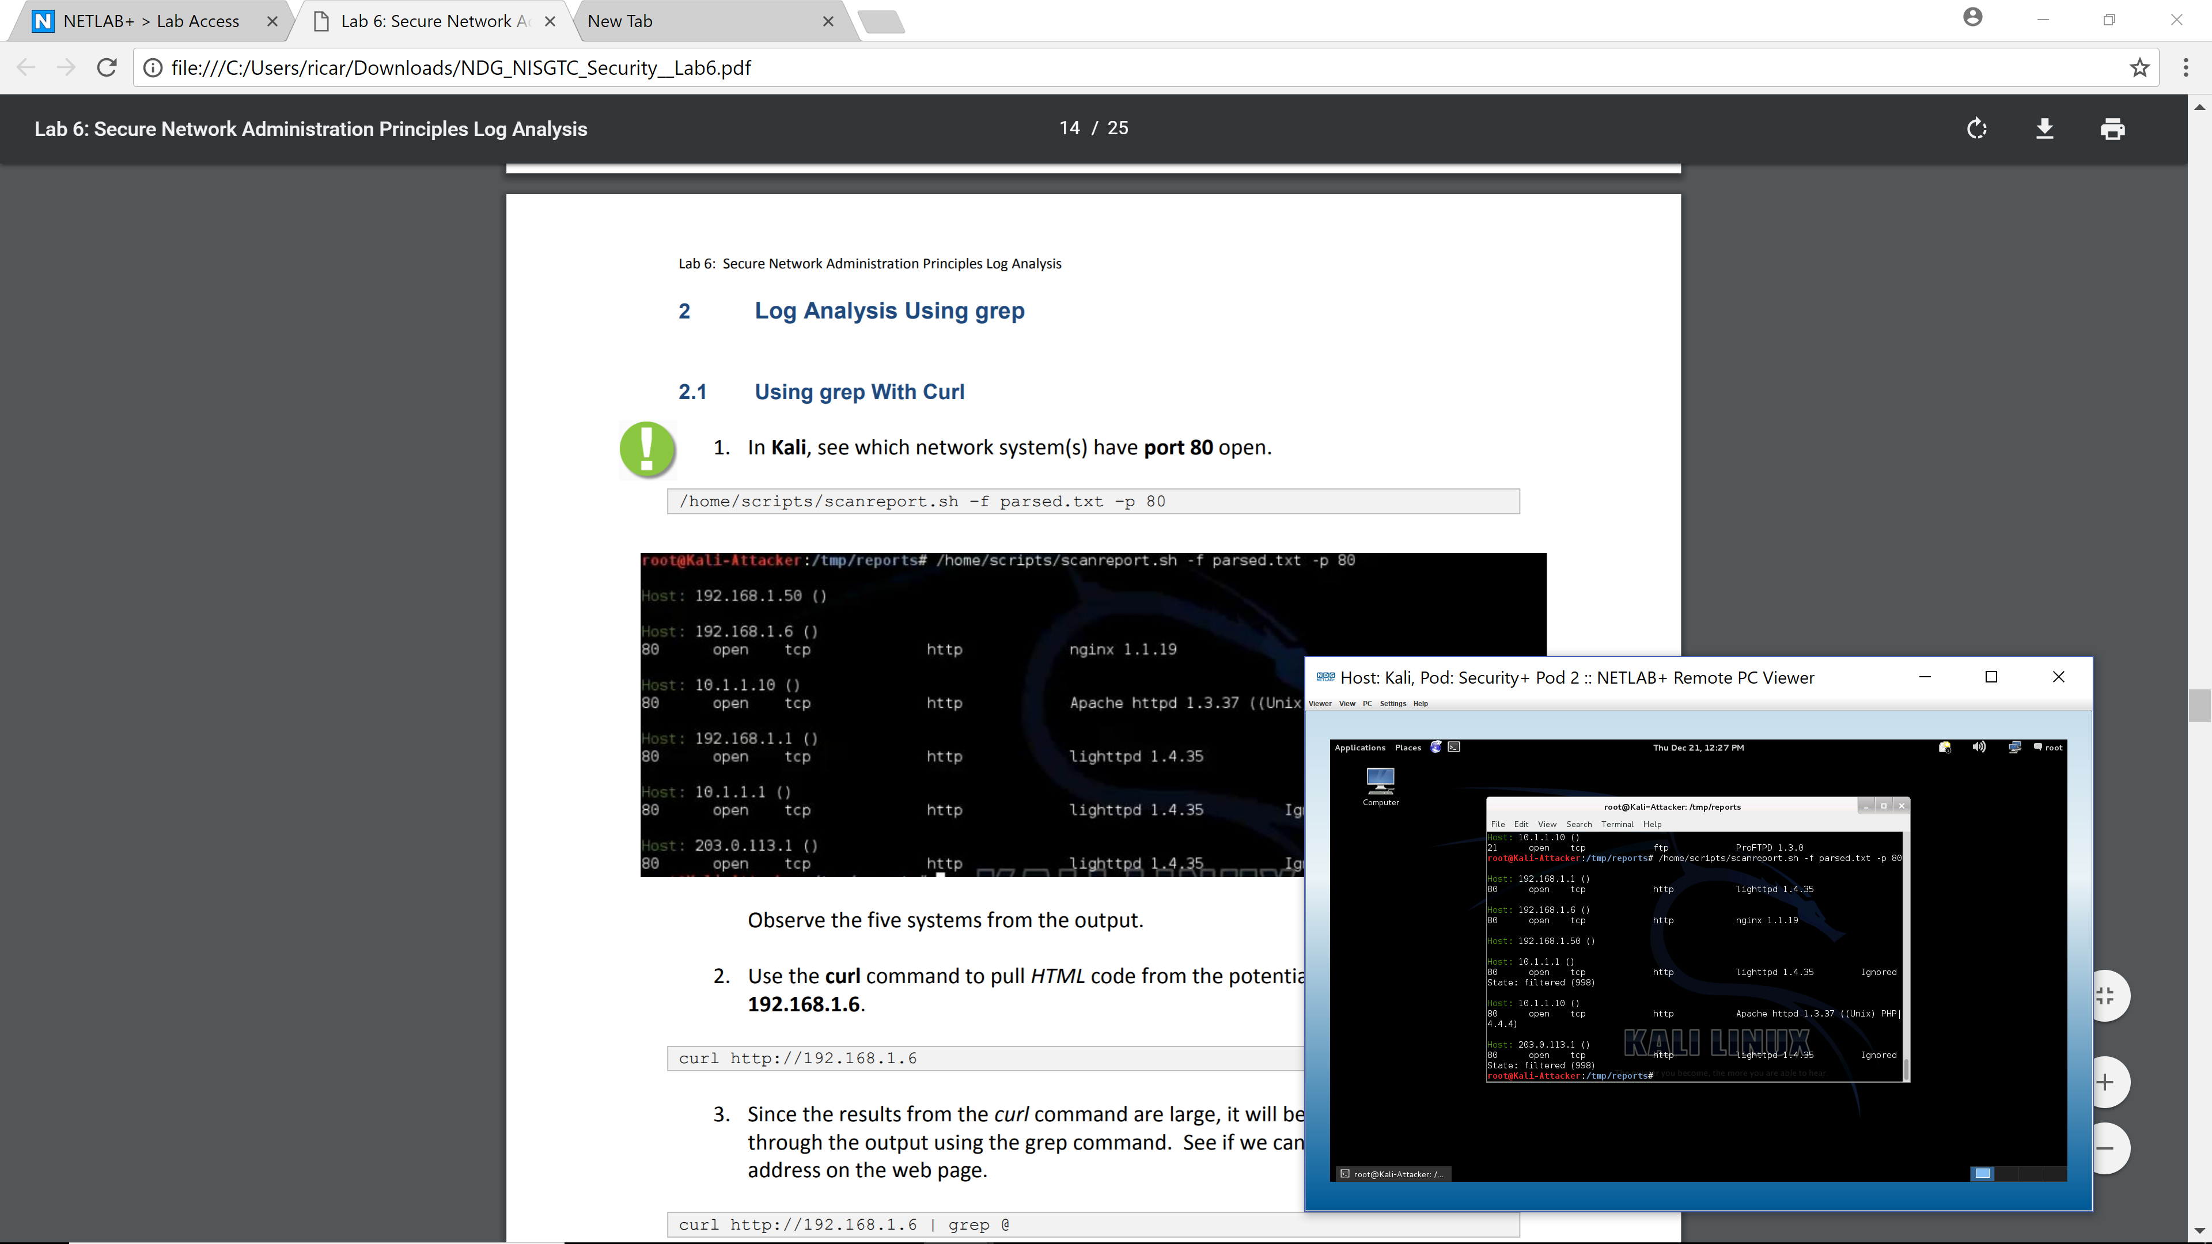
Here we observe the systems from the output in kali. Port 80 is displayed.

Email displayed
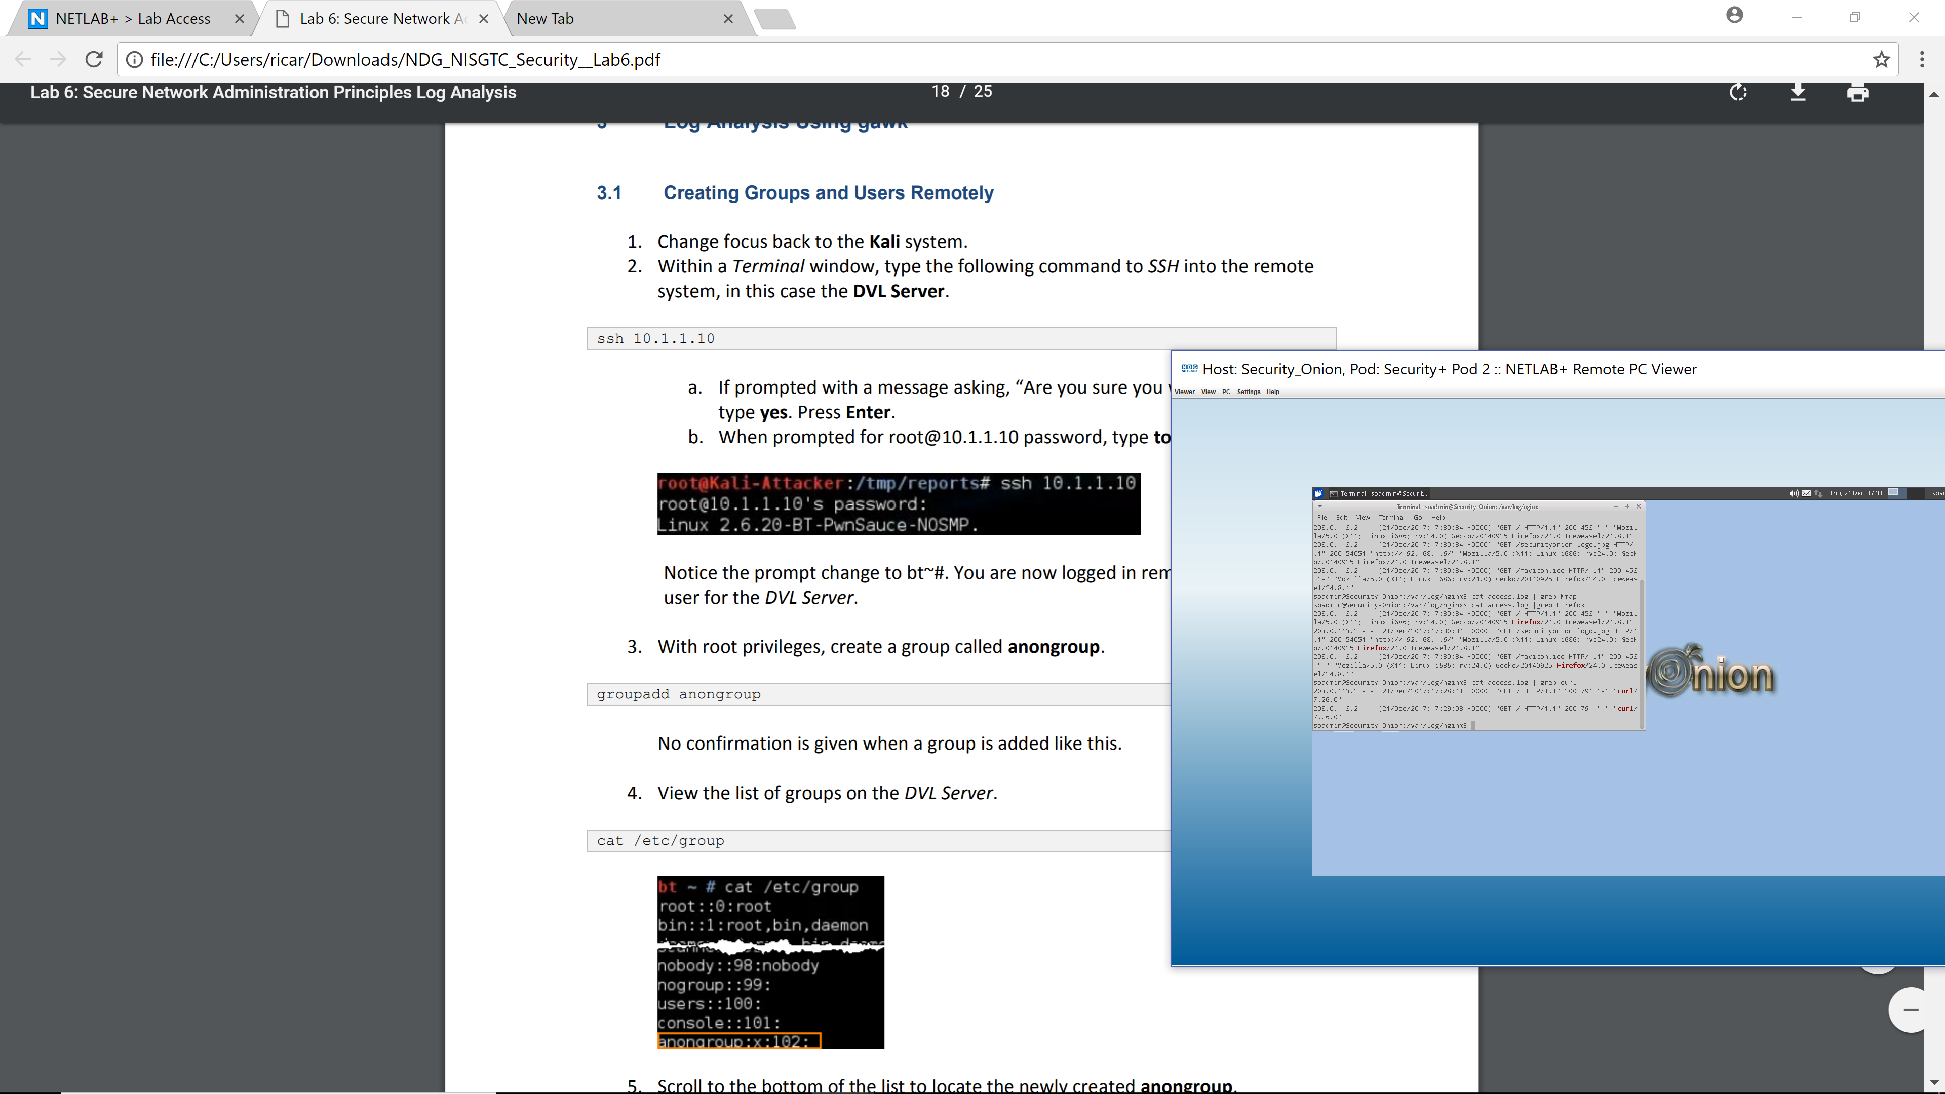
Word curl log file accessed.

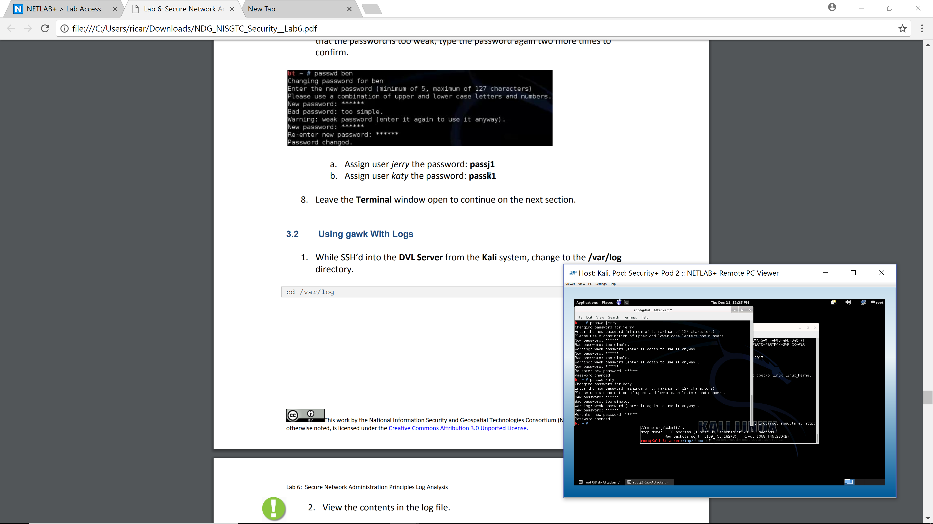
Passwords changed and users added

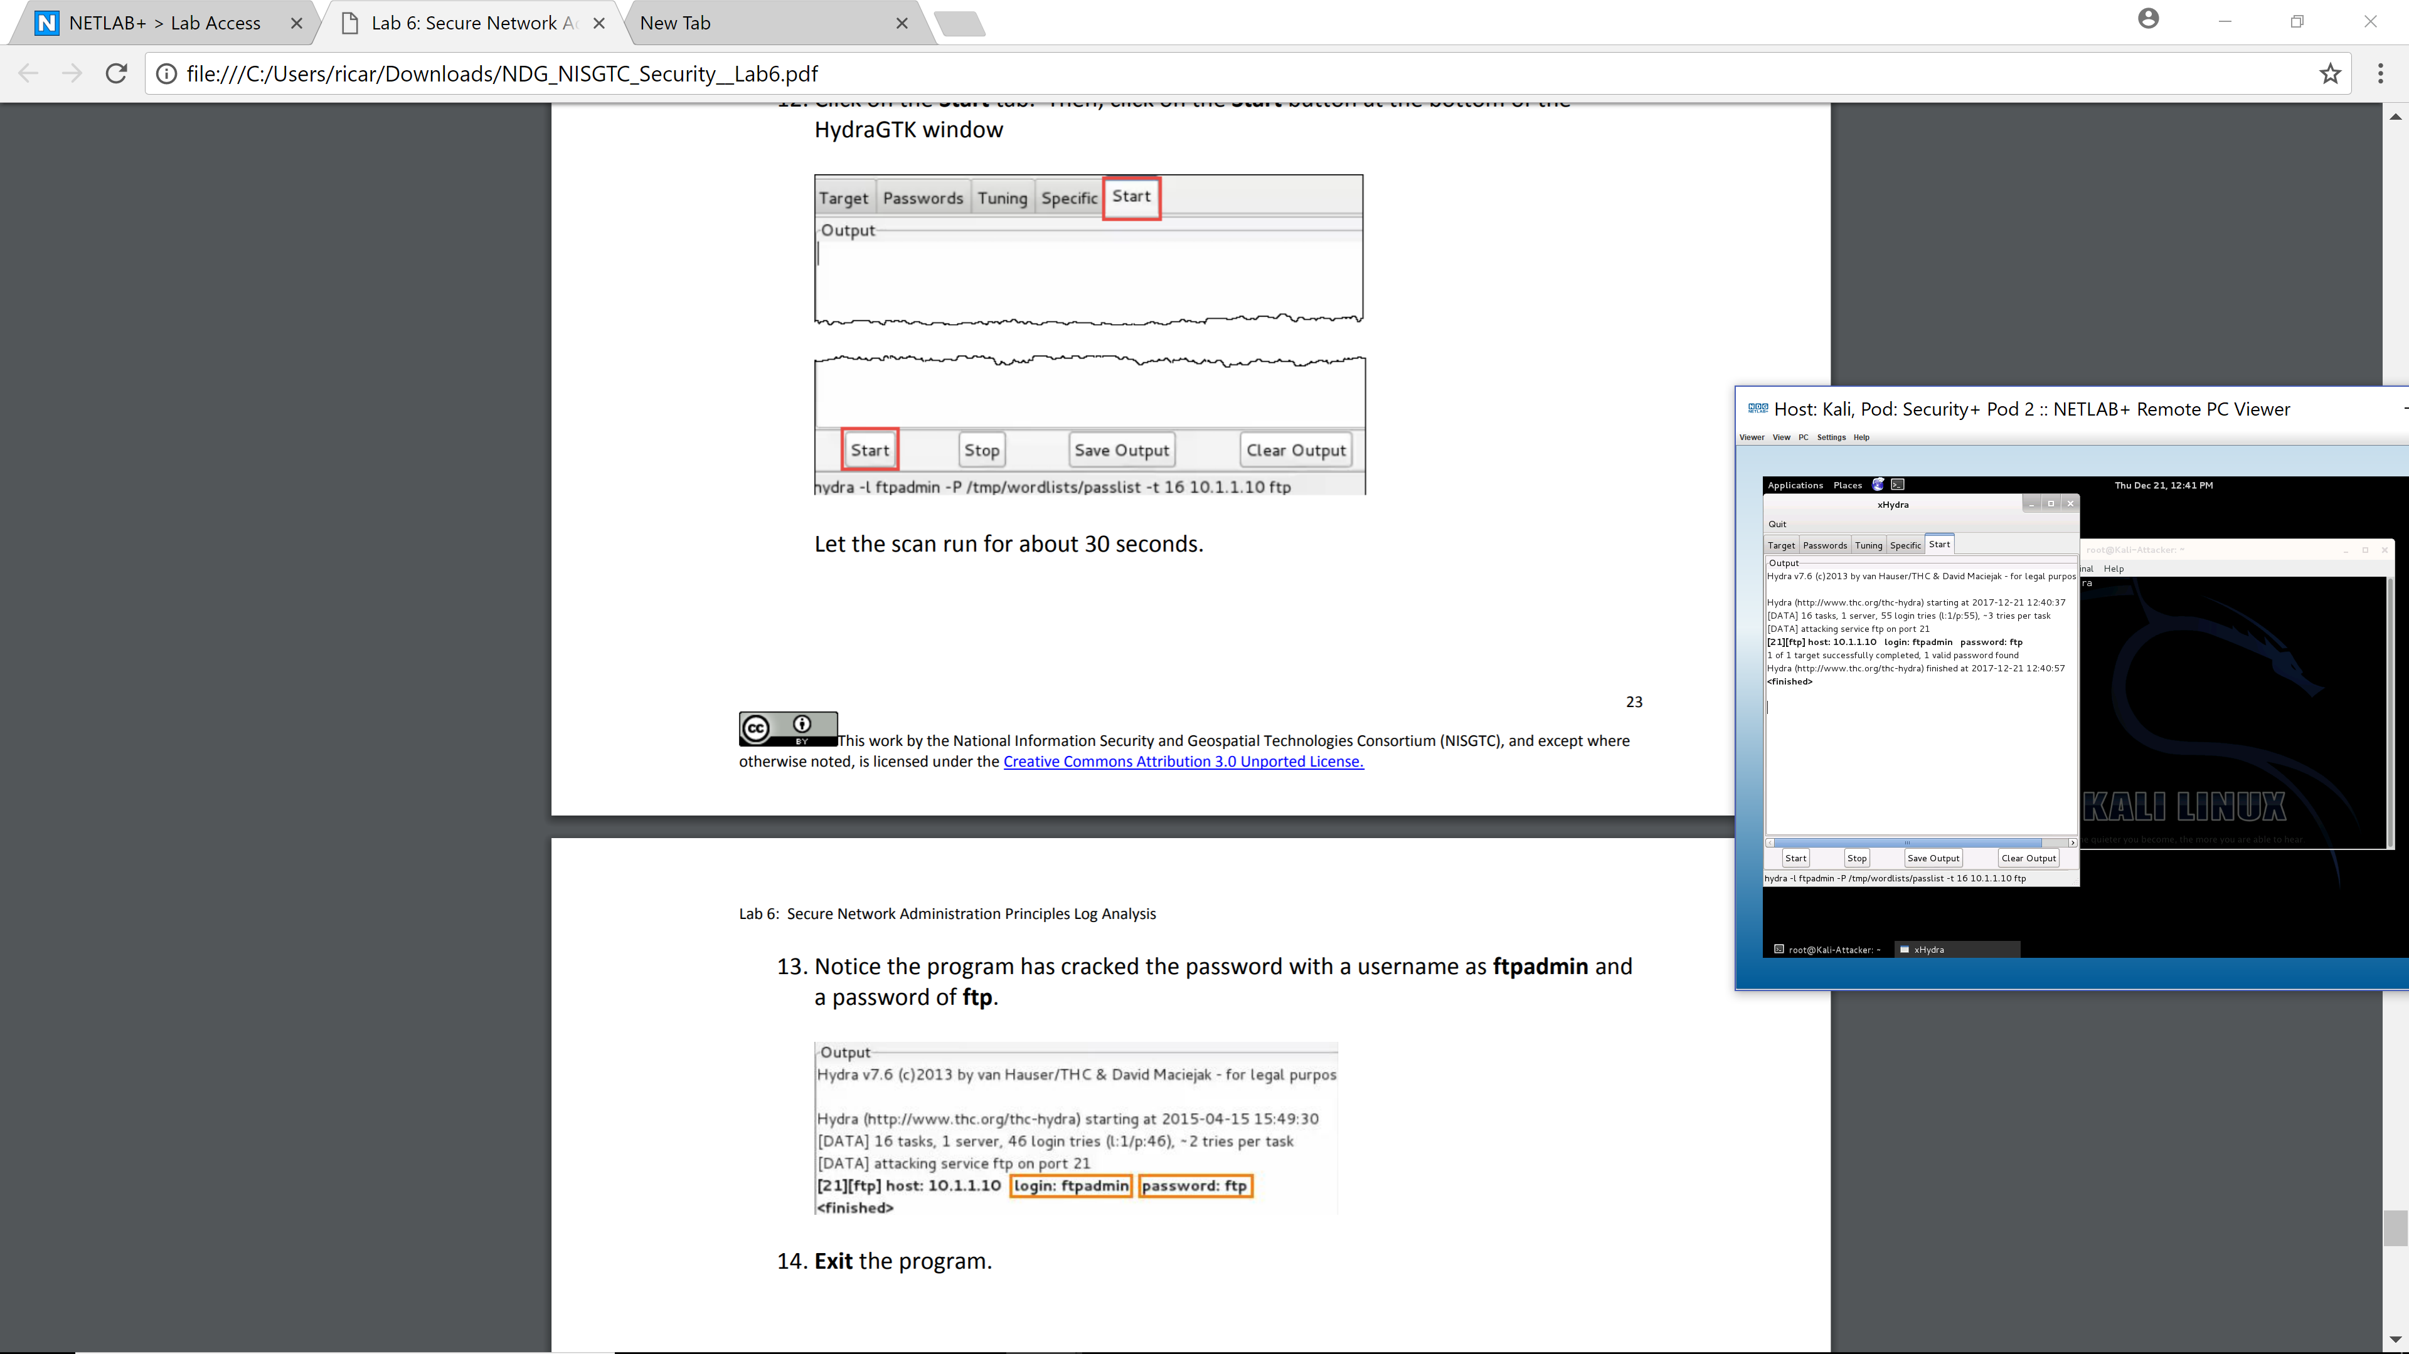
Psswd cracked


